ANNEX Q

Hazardous Materials
and Oil Spill Response

Wood County

and the Cities of:
Alba, Hawkins,
Mineola, Quitman,
Winnsboro & Yantis

RECORD OF CHANGES

CHANGE # | DATE OF CHANGE | DESCRIPTION | CHANGED BY
01 | 07-21-2017 | Update entire annex | Tully Davidson

APPROVAL & IMPLEMENTATION

Annex Q

Hazardous Materials

& Oil Spill Response

                - This annex is hereby approved for implementation effective August 31, 2017, and supersedes all previous editions.

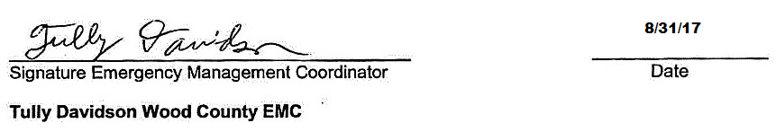

ANNEX Q
HAZARDOUS MATERIAL & OIL SPILL RESPONSE

AUTHORITY

A. Federal

1. Public Law 96-510, Comprehensive Environmental Response Compensation and Liability Act of 1980.
2. Public Law 99-499, Emergency Planning and Community Right to Know Act of 1986.
3. 29 CFR 1910.120, Hazardous Waste Operations and Emergency Response.
4. 40 CFR 68, Clean Air Act.
5. 40 CFR 261, Resource Conservation and Recovery Act

B. State

1. Texas Health and Safety Code, Chapter 502, Texas Hazard Communication Act.
2. Texas Health and Safety Code, Chapter 505, Manufacturing Facility Community Right-to-Know Act.
3. Texas Health & Safety Code, Chapter 506,Public Employer Community Right-to-Know Act.
4. Texas Health and Safety Code, Chapter 507, Non-manufacturing Facilities Community Right-to-Know Act.

C. Local

See Basic Plan, Section I.

PURPOSE

                - This annex establishes the policies and procedures under which Wood County and its Cities will operate in the event of a hazardous material incident or oil spill. It defines the roles, responsibilities and organizational relationships of government agencies and private entities in responding to and recovering from an oil spill or incident involving the transport, use, storage, or processing of hazardous material.

EXPLANATION OF TERMS

A. Acronyms

CAA Clean Air Act
CERCLA Comprehensive Environmental Response, Compensation, and
Liability Act of 1980
CHEMTREC Chemical Transportation Emergency Center
DPS Department of Public Safety
DSHS Department of State Health Services
EHS Extremely Hazardous Substances
EMC Emergency Management Coordinator
EPCRA Emergency Planning, Community Right-to-Know Act of 1986
ERG Emergency Response Guide (U.S. Department of Transportation)
TDEM Texas Division of Emergency Management
GLO General Land Office
HC Hazardous chemicals
HS Hazardous substances
ICS Incident Command System
ICP Incident Command Post
LEPC Local Emergency Planning Committee
MSDS Material Safety Data Sheet
NIMS National Incident Management System
NRC National Response Center
NRF National Response Framework
OSHA Occupational Safety and Health Administration
PPE Personal Protective Equipment
RCRA Resource Conservation and Recovery Act
RMP Risk Management Plan
RRC Railroad Commission
RRT Regional Response Team
SARA III Superfund Amendments and Reauthorization Act of 1986, Title III
(Also known as EPCRA)
SERC State Emergency Response Commission
SERT State Emergency Response Team
SOC State Operation Center
SONS Spill of National Significance
SOP Standard operating procedures
TCRA Texas Community Right to Know Act(s)
TCEQ Texas Commission on Environmental Quality
TxDOT Texas Department of Transportation

B. Definitions

1. Accident site. The location of an unexpected occurrence, failure, or loss, either at a regulated facility or along a transport route, resulting in a release of listed chemicals.

2. Acute exposure. Exposures, of a short duration, to a chemical substance that will result in adverse physical symptoms.

3. Acutely toxic chemicals. Chemicals which can cause both severe short term and long term health effects after a single, brief exposure of short duration. These chemicals can cause damage to living tissue, impairment of the central nervous system and severe illness. In extreme cases, death can occur when ingested, inhaled, or absorbed through the skin.

4. CHEM-TEL. Provides emergency response organizations with a 24-hour phone response for chemical emergencies. CHEM-TEL is a private company listed in the Emergency Response Guidebook.

5. CHEMTREC. The Chemical Transportation Emergency Center (CHEMTREC) is a centralized toll-free telephone service providing advice on the nature of chemicals and steps to be taken in handling the early stages of transportation emergencies where hazardous chemicals are involved. Upon request, CHEMTREC may contact the shipper, National Response Center, and manufacturer of hazardous materials involved in the incident for additional, detailed information and appropriate follow-up action, including on-scene assistance when feasible.

6. Cold Zone. The area outside the Warm Zone (contamination reduction area) that is free from contaminants.

7. Extremely hazardous substances (EHS). Substances designated as such by the EPA pursuant to the Emergency Planning and Community Right-to-Know Act (EPCRA). EHS inventories above certain threshold quantities must be reported annually to the SERC, LEPCs, and local fire departments pursuant to Section 312 of EPCRA and Texas community right-to-know acts (TCRAs). EHS releases which exceed certain quantities must be reported to the National Response Center, the SERC, and local agencies pursuant to Section 304 of EPCRA and state regulations. The roughly 360 EHSs, and pertinent reporting quantities, are listed in 40 CFR 355.

8. Hazard. The chance that injury or harm will occur to persons, plants, animals or property.

9. Hazard analysis. Use of a model or methodology to estimate the movement of hazardous materials at a concentration level of concern from an accident site at fixed facility, or on a transportation route to the surrounding area, to determine which portions of a community may be affected by a release of such materials.

10. Hazardous chemicals (HC). Chemicals, chemical mixtures, and other chemical products determined by US Occupational Health and Safety Administration (OSHA) regulations to pose a physical or health hazard. No specific list of chemicals exists, but the existence of a Material Safety Data Sheet (MSDS) for a product indicates it is a hazardous chemical. Facilities that maintain more than 10,000 pounds of a HC at any time are required to report inventories of such chemicals annually to the SERC in accordance with TCRAs.

11. Hazardous material (Hazmat). A substance in a quantity or form posing an unreasonable risk to health, safety and/or property when manufactured, stored, or transported in commerce. A substance which by its nature, containment, and reactivity has the capability for inflicting harm during an accidental occurrence, characterized as being toxic, corrosive, flammable, reactive, an irritant, or a strong sensitizer and thereby posing a threat to health and the environment when improperly managed. Includes EHSs, HSs, HCs, toxic substances, certain infectious agents, radiological materials, and other related materials such as oil, used oil, petroleum products, and industrial solid waste substances.

12. Hazardous substance (HS). Substances designated as such by the EPA pursuant to the Comprehensive Environmental Response, Compensation, and Liability Act (CERCLA). Facilities, which have more than 10,000 pounds of any HS at any time, are required to report inventories of such substances annually to the SERC in accordance with TCRAs. HS releases above certain levels must be reported to the National Response Center, the SERC, and local agencies pursuant to the CERCLA, Section 304 of EPCRA, and state regulations. The roughly 720 HS and pertinent reporting quantities are listed in 40 CFR 302.4.

13. Hot Zone. The area surrounding a particular incident site where contamination does or may occur. All unauthorized personnel may be prohibited from entering this zone.

14. Incident Commander. The overall coordinator of the response team. Responsible for on-site strategic decision and actions throughout the response phase. Maintains close liaison
with the appropriate government agencies to obtain support and provide progress reports on each phase of the emergency response. Must be trained to a minimum of operations level and certified in the Incident Command System (ICS).

15. Incident Command System. A standardized on-scene emergency management system specifically designed to provide for the adoption of an integrated organizational structure that reflects the complexity and demands of single or multiple incidents, without being hindered by jurisdictional boundaries. ICS is the combination of facilities, equipment, personnel, procedures, and communications operating within a common organizational structure, designed to aid in the management of resources during incidents. ICS is used for all emergency responses and is applicable to small, as well as, large and complex incidents. ICS is used by various jurisdictions and functional agencies, both public and private, or organized field-level incident management.

16. National Response Center (NRC). Interagency organization, operated by the US Coast Guard, that receives reports when reportable quantities of dangerous goods and hazardous substances are spilled. After receiving notification of an incident, the NRC will immediately notify appropriate federal response agencies, which may activate the Regional Response Team or the National Response Team.

17. National Incident Management System (NIMS). The system mandated by HSPD-5 that provides a consistent nationwide approach for Federal, State, local, and tribal governments; the private sector; and non-governmental organizations to work effectively and efficiently together to prepare for, respond to, and recover from domestic incidents, regardless of cause, size, or complexity, the NIMS includes a core set of concepts, principles, and terminology.

18. On-scene. The total area that may be impacted by the effects of a hazardous material incident. The on-scene area is divided into mutually exclusive on-site and off-site areas.

19. Plume. A vapor cloud formation that has shape and buoyancy. The cloud may be colorless, tasteless, odorless, and may not be visible to the human eye.

20. Regulated facility. A plant site where handling/transfer, processing, and/or storage of chemicals is performed. For the purposes of this annex, regulated facilities (1) produce, use, or store EHSs in quantities which exceed threshold planning quantities or (2) hold one or more HCs in a quantity greater than 10,000 pounds at any time. Facilities that meet either criterion must annually report their inventories of such materials to the SERC, local LEPCs, and the local fire department in accordance with TCRAs.

21. Reportable quantity. The minimum quantity of hazardous material released, discharged, or spilled that must be reported to federal state and/or local authorities pursuant to statutes and regulations.

22. Response. The efforts to minimize the hazards created by an emergency by protecting the people, environment, and property and returning the scene to normal pre-emergency conditions.

23. Risk Management Plan (RMP). Pursuant to section 112r of the CAA, facilities that produce, process, distribute or store 140 toxic and flammable substances are required to have a RMP that includes a hazard assessment, accident prevention program, and emergency response program. A summary of the RMP must be submitted electronically to the EPA; it can be accessed electronically by local governments and the public.

24. Spill of National Significance (SONS). A spill or discharge oil or hazardous material as defined by the National Oil and Hazardous Substance Contingency Plan (NCP) that occurs either in an inland zone or a coastal zone that requires a response effort so complex that it requires extraordinary coordination of Federal, State, local, and other resources to contain or clean up. Authority to declare a SONS in an inland zone is granted to the EPA Administrator. For discharges in a coastal zone the United States Coast Guard Commandant may declare a SONS. The Department of Homeland Security may classify a SONS as an incident of national significance.

25. Toxic substances. Substances believed to produce long-term adverse health effects. Facilities which manufacture or process more than 25,000 pounds of any designated toxic substance or use more than 10,000 pounds of such substance during a year are required to report amounts released into the environment annually to the SERC and the EPA. This list of toxic substances covered is contained in 40 CFR 372.

26. Vulnerable Facilities. Facilities which may be of particular concern during an hazmat incident because they:

- Are institutions with populations that are particularly vulnerable or could require substantial assistance during an evacuation (schools, hospitals, nursing homes, day care centers, jails),

b. Fulfill essential population support functions (power plants, water plants, the fire/police/EMS dispatch center), or

c. Include large concentrations of people (shopping centers, recreation centers)

27. Warm Zone: An area over which the airborne concentration of a chemical involved in an incident could reach a concentration that may cause serious health effects to anyone exposed to the substance for a short period of time.

SITUATION & ASSUMPTIONS

A. Situation

- Hazardous materials are commonly used, transported, and produced in the local area; hence, Hazmat incidents may occur here.

- We have the lead in the initial response to a Hazmat incident that occurs within our jurisdictions. Hazmat response resources are listed in Annex M, Resource Management. Our Hazmat incident response capability may be summarized as: awareness only; must call neighboring jurisdictions or private company personnel for response. There are no hazardous materials technicians in any of our volunteer fire departments; bunker gear is the only available protective clothing.

- Although radiological materials are considered hazardous materials in most classification schemes, detailed planning for incidents involving these materials are covered in Annex D, Radiological Protection, to this plan.

- Vulnerable facilities potentially at risk from a Hazmat release are identified in Appendix 5.

- Regulated facilities that may create a Hazmat risk in the local area are identified in Appendix 6.

  - Hazardous materials transportation routes that may pose a threat to the local area are identified in Appendix 7.

  - Evacuation routes from risk areas surrounding regulated facilities are described in Appendix 8.

  - Pursuant to the EPCRA, a local fire chief has the authority to request and receive information from regulated facilities on hazardous material inventories and locations for planning purposes and may conduct an on-site inspection of such facilities.

  - If we are unable to cope with an emergency with our own resources and those available through mutual aid, the State may provide assistance. When requested by the State, assistance may also be provided by federal agencies.

  - The Wood County Local Emergency Planning Committee is responsible for providing assistance to the County and Cities in hazardous materials planning.

  - Emergency worker protection standards provide that personnel may not participate in the response to a Hazmat incident unless they have been properly trained and are equipped with appropriate personal protective equipment. See Appendix 3.

B. Assumptions

1. An accidental release of Hazmat could pose a threat to the local population or environment. A hazardous materials incident may be caused by or occur during another emergency, such as flooding, a major fire, or a tornado.

2. A major transportation Hazmat incident may require the evacuation of citizens at any location within the county.

3. Regulated facilities will report Hazmat inventories to local fire departments and the LEPC.

4. In the event of a Hazmat incident, regulated facilities and transportation companies will promptly notify us of the incident and make recommendations to local emergency responders for containing the release and protecting the public.

5. In the event of a Hazmat incident, we will determine appropriate protective action recommendations for the public, disseminate such recommendations, and implement them.

6. The length of time available to determine the scope and magnitude of a hazmat incident will impact protective action recommendations.

7. During the course of an incident, wind shifts and other changes in weather conditions may necessitate changes in protective action recommendations.

8. If an evacuation is recommended because of an emergency, typically 80% of the population in an affected area will relocate voluntarily when advised to do so by local authorities. Some residents will leave by routes other than those designated by emergency personnel as evacuation routes. Some residents of unaffected areas may also evacuate spontaneously. People who evacuate may require shelter in a mass care facility.

9. Hazardous materials entering water or sewer systems may necessitate the shutdown of those systems.

10. The Wood County Local Emergency Planning Committee (LEPC) will assist the County and Cities in preparing and reviewing hazardous material response plans and procedures.

CONCEPT OF OPERATIONS

A. Prevention

Hazardous materials prevention is undertaken to reduce/prevent a threat to lives and property during a Hazmat incident. Our hazardous materials prevention activities include:

1. We have performed a chemical hazard analysis to identify the types and quantities of hazardous materials present in the community at fixed sites or on transportation routes, potential release situations, and possible impact on the local population.

2. We receive and maintain data on the Hazmat inventories at local regulated facilities for use in emergency planning. Regulated facilities are identified in Appendix 6 to this annex.

- We have identified local hazmat transportation routes; these are depicted in Appendix 7 to this annex.

- We have established approved routes for hazardous cargo, depicted in Appendix 7.

  - The local Volunteer Fire Departments perform periodic inspection of facilities that produce, use, or store hazardous materials.

  - The Wood County Fire Marshal’s Office monitors land use/zoning to ensure local officials are made aware of plans to build or expand facilities that make, use, or store hazardous materials so the potential impact of such facilities can be assessed and minimized. Each city has zoning regulations, and employs inspectors to enforce those.

B. Preparedness

To enhance the preparedness of its emergency responders and the public, we have:

1. Developed public education programs on chemical hazards and related protective actions.

2. Trained some emergency personnel to be aware of Hazmat response dangers, and instructed them to call for assistance if needed. DOT Hazmat guides are kept in each public vehicle. See Appendix 3.

3. Identified emergency response resources for Hazmat incidents. See Annex M, Resource Management.

4. Met periodically with regulated facilities and known Hazmat transporters to ensure that company and local emergency plans are coordinated to the extent possible and that emergency contact information is kept up-to-date.

C. Response

1. Incident Classification. To facilitate the proper incident response, a three-level incident classification scheme will be used. The incident will be initially classified by the first responder on the scene and updated by the incident Commander as required.

a. Level I – Incident. An incident is a situation that is limited in scope and potential effects; involves a limited area and/or limited population; evacuation or sheltering in place is typically limited to the immediate area of the incident; and warning and public instructions are conducted in the immediate area, not community-wide. This situation can normally be handled by one or two local response agencies or departments acting under an Incident Commander (IC), and may require limited external assistance from other local response agencies or contractors.

b. Level II – Emergency. An emergency is a situation that is larger in scope and more severe in terms of actual or potential effects than an incident. It does or could involve a large area, significant population, or critical facilities; require implementation of large-scale evacuation or sheltering in place and implementation of temporary shelter and mass care operations; and require community-wide warning and public instructions. You may require a sizable multi-agency response operating under an IC; and some external assistance from other local response agencies, contractors, and limited assistance from state and federal agencies.

c. Level III – Disaster. A disaster involves the occurrence or threat of significant casualties and/or widespread property damage that is beyond the capability of the local government to handle with its organic resources. It involves a large area, a sizable population, and/or critical resources; may require implementation of large-scale evacuation or sheltering in place and implementation of temporary shelter and mass care operations and requires a community-wide warning and public instructions. This situation requires significant external assistance from other local response agencies, contractors, and extensive state or federal assistance.

2. Initial Reporting

a. It is anticipated that a citizen who discovers a hazardous material incident will immediately notify the County or City through the 9-1-1 system and provide some information on the incident.

b. Any public sector employee discovering an incident involving the potential or actual release of hazardous material should immediately notify the Emergency Communications Center and provide as much of the information required for the Hazardous Materials Incident Report in Appendix 2 as possible.

c. Operators of regulated facilities and Hazmat transportation systems are required by law to report certain types of Hazmat releases. For Hazmat incidents occurring at regulated facilities, a facility representative at a regulated site is expected to immediately notify the Emergency Communications Center and provide information for a Hazardous Materials Incident Report; see Appendix 2.

3. Notification

Upon receiving a Hazardous Materials Incident report, the Emergency Communications Center will initiate responder notifications commensurate with the incident classification (Level I, II, or III) in accordance with its Communications SOP.

4. Response Activities

a. The first firefighter or law enforcement officer on the scene should initiate the Incident Command System (ICS), establish an Incident Command Post (ICP), and begin taking the actions listed in the General Hazmat Response Checklist in Appendix 1. If the situation requires immediate action to isolate the site and evacuate nearby residents, the first officer on the scene should advise the Emergency Communications Center and begin such actions.

b. As other responders arrive, the senior firefighter will generally assume the role of IC for Hazmat emergencies and continue taking the actions listed in the General Hazmat Response Checklist.

c. The EOC may be activated for a Level II (Emergency) response and will be activated for Level III (Disaster) response.

d. ICP - EOC Interface

1) If the EOC is activated the IC and the EOC shall agree on and implement an appropriate division of responsibilities for the actions listed in the General Hazmat Response Checklist.

2) Regular communication between the ICP and the EOC regarding checklist actions is required to ensure that critical actions are not inadvertently omitted.

e. Determining Affected Areas and Protective Actions

      - The IC shall estimate areas and population affected by a Hazmat release, and may be assisted by the EOC in that process. Aids for determining the size of the area affected may include:

        - The Emergency Response Guidebook
        - Computerized release modeling using CAMEO / ALOHA and other software
        - Assistance by the responsible party
        - Assistance by expert sources such as CHEMTREC or CHEM-TEL
        - Assistance by state and federal agencies

2) The IC shall determine required protective actions for response personnel and the public, and may be aided in determining protective actions for the public by the EOC. See Appendix 3 for emergency responder safety considerations. See Appendix 4 for public protective action information.

      - The IC will typically provide warning to and implement protective actions for the public in the immediate vicinity of the incident site. The EOC will normally oversee dissemination of warning and implementation of protective actions for the public beyond the immediate incident site and related activities such as traffic control and activation of shelters. Sample public warning and protective action messages are provided in Annex A, Warning. Additional information on public information is provided in Annex I, Emergency Public Information.

f. Release Containment

1) The responsibility for selecting and implementing appropriate measures to contain the release of hazardous materials is assigned to the IC, who may obtain advice from the responsible party, state and federal agencies, and appropriate technical experts.

2) Containment methods may include construction or use of berms, dikes, trenches, booms and other deployable barriers, stream diversion, drain installation, catch basins, patching or plugging leaking containers, reorientation of containers, freeing of valves, or repackaging.

D. Recovery

1. When the initial response to an incident has ended, further effort may be required to control access to areas, which are still contaminated, clean up and dispose of spilled materials, decontaminate and restore areas, which have been affected, and recover response costs from the responsible party. The recovery process may continue for an extended period.

2. The spiller is, by common law, responsible for all cleanup activities. Most recovery activities will be conducted by contractors, paid for by the responsible party, and overseen by state and federal authorities. Methods of cleanup may include excavating, pumping and treating, dredging, skimming, dispersion, vacuuming, and biological remediation. Dilution is prohibited as a substitute for treatment.

3. The County Judge or Mayor will appoint a recovery coordinator to oversee recovery efforts and serve as the local government point of contact with the responsible party, cleanup contractors, and state and federal agencies. For major incidents, it may be desirable to designate a recovery team consisting of a coordinator and representatives of the various departments and local agencies who have an interest in recovery activities.

4. The recovery coordinator or team should:

a. Ensure access controls are in place for contaminated areas that cannot be cleaned up immediately.

b. Ensure documentation and cost data relating to the incident response is preserved and maintain a list of such records which indicates their locations to facilitate claims against the responsible party and/or reimbursement by the state or federal government.

c. Review plans for cleanup and restoration proposed by the responsible party or state or federal agencies and then monitors their implementation.

d. Monitor the removal and disposition of hazardous materials, contaminated soil and water, and contaminated clothing.

e. Review proposed mitigation programs and monitor their implementation.

ORGANIZATION & ASSIGNMENT OF RESPONSIBILITIES

A. General

  - Our normal emergency organization, described in Section VI.A of the Basic Plan and depicted in Attachment 3 to the Basic Plan, will be employed to respond to and recover from incidents involving hazardous materials or oil spills.

  - Effective response to a Hazmat incident or oil spill may also require response assistance from the company responsible for the spill and, in some situations, by state and federal agencies with responsibilities for Hazmat spills. Technical assistance for a Hazmat incident may be provided by the facility, by industry, or by state and federal agencies.

B. Assignment of Responsibilities

1. Community Emergency Coordinator

a. The Wood County EMC shall serve as the Community Emergency Coordinator for Hazmat issues, as required by EPCRA.

b. The Community Emergency Coordinator will:

1) Coordinate with the emergency coordinators of regulated facilities and vulnerable facilities to maintain the list of regulated facilities in Appendix 6 and the list of vulnerable facilities in Appendix 5.

2) Maintain an accurate and up-to-date Hazmat emergency contact roster that provides 24-hour contact information for regulated facilities, local Hazmat transportation companies, vulnerable facilities, state and federal Hazmat response agencies, and technical assistance organizations such as CHEMTREC. Disseminate this roster to local emergency responders.

3) Ensure each regulated facility and local Hazmat transportation company is notified of the telephone number to be used to report hazmat incidents to local authorities.

4) Coordinate the review of regulated facility emergency plans by local officials.

2. The local Volunteer Fire Department will:

    - Carry out the general fire service responsibilities outlined in Annex F (Firefighting).

    - Normally provide the IC for a hazardous materials response operation.

3. The Incident Commander will:

    - Establish a command post.

    - Determine and communication the incident classification.

    - Take immediate steps to identify the hazard and pass that information to the Emergency Communications Center, who should disseminate it to emergency responders.

    - Determine a safe route into the incident site and advise the Emergency Communications Center, who should relay that information to all emergency responders.

    - Establish the Hazmat incident functional areas (Hot Zone, Warm Zone, Cold Zone) and a staging area.

    - Initiate appropriate action to control and eliminate the hazard in accordance with SOP.

      - If the EOC is not activated, ensure that the tasks outlined in the General Hazmat Response Checklist in Appendix 1 are accomplished.

      - If the EOC is activated for a Level II or III incident, coordinate a division of responsibility between the ICP and EOC for the tasks outlined in the General Hazmat Response Checklist. In general, the ICP should handle immediate response tasks and the EOC should handle support tasks that require extensive planning or coordination.

4. Law Enforcement will:

a. Maintain a radio-equipped officer at the ICP until released by the IC.

b. Evacuate citizens when requested by the IC. Advise the Emergency Communications Center and the EOC regarding the status of the evacuation. Make requests for assistance to the fire department, as necessary.

c. Control access to the immediate incident site for safety and limit entry to authorized personnel only. The IC will determine the size and configuration of the cordon.

(1) Entry of emergency personnel into the incident area should be expedited. The IC will provide information on safe routes.

(2) Persons without a valid reason for entry into the area, and who insist on right of entry, will be referred to the ICP or ranking law enforcement officer on duty for determination of status and/or legal action.

d. Perform traffic control in and around the incident site and along evacuation routes.

e. Provide access control to evacuated areas to prevent theft.

f. Provide assistance in determining the number and identity of casualties.

5. The EMC will:

    - Coordinate with the IC and based upon the incident classification and recommendations of the IC, initiate activation of the EOC through the Emergency Communications Center.

    - If the EOC is activated:

1) Coordinate a specific division of responsibility between the IC and EOC for the tasks outlined in the General Hazmat Response Checklist. In general, the ICP should handle immediate response tasks and the EOC support tasks that which require extensive planning or coordination.

2) Carry out required tasks

        - Provide support requested by the IC.

        - For Level II and III incidents, ensure elected officials and the County or City attorney are notified of the incident and the circumstances causing or surrounding it.

  - EMS will:

    - Provide medical treatment for casualties.

    - Transport casualties requiring further treatment to medical facilities.

  - The local Public Works or Road & Bridge Department will:

a. Provide heavy equipment and materials for spill containment.

b. When requested, provide barricades to isolate the incident site.

c. Cooperate with law enforcement to detour traffic around the incident site.

  - The local Water & Sewer Department, Utility or Utilities will:

a. When notified of an incident, which may impact water or sewer systems, take precautionary actions to prevent damage to those systems.

b. If a Hazmat incident impacts water or sewer systems, check systems for damage and restore service.

c. When appropriate, provide inputs to the IC or EOC for protective actions for the public relating to water and sewer systems.

  - Regulated Facilities / Hazmat Transportation Companies are expected to:

a. Provide current emergency contact numbers to local authorities.

b. Upon request, provide planning support for accidental release contingency planning by local emergency responders.

c. In the event of a Hazmat incident:

1) Make timely notification of the incident to local officials and other agencies as required by state and federal law.

2) Provide accident assessment information to local emergency responders.

3) Make recommendations to local responders for containing the release and protecting the public.

4) Carry out emergency response as outlined in company or facility emergency plans to minimize the consequences of a release.

5) Assist local responders as outlined in mutual aid agreements.

6) Provide follow-up status reports on an incident until it is resolved.

7) Clean up or arrange for the cleanup of Hazmat spills for which the company is responsible.

d. Regulated facilities are also required to:

1) Report Hazmat inventories to the SERC, LEPC, and local fire department at required by federal and state statutes and regulations.

2) Provide MSDSs for hazardous materials produced or stored on-site, as required to the LEPC and local fire department(s).

3) Designate a facility emergency coordinator.

4) Develop an on-site emergency plan that specifies notification and emergency response procedures and recovery actions. Facilities covered by the Clean Air Act (CAA) 112(r) are required to have a more extensive Risk Management Plan (RMP); a summary of which must be filed with the EPA. Local officials can access that information via the Internet.

5) Coordinate the on-site emergency plan with local officials to ensure that the facility emergency plan complements the local emergency plan and does not conflict with it.

  - State Government.

a. If local resources and mutual aid resources available to respond to a Hazmat incident are inadequate or inappropriate, we will request state assistance from the Disaster District Committee (DDC) Chairperson in Tyler. The DDC Chairperson is authorized to employ those state resources within the district, except that use of Texas Military Forces (TMF) requires approval of the Governor. If the state resources within the District are inadequate, the DDC Chairperson will forward our request to the State Operations Center (SOC) for action.

b. For major incidents, the SOC will coordinate state assistance that cannot be provided by the DDC and request federal assistance, if required.

c. The TCEQ:

      - Serves as the lead state agency for response to most hazardous materials and inland oil spills.
      - Serves in an advisory role to the federal on-scene coordinator if federal resources are provided.
      - Monitors all cleanup and disposal operations and coordinates with other state agencies.

      - Determines the adequacy of containment and cleanup operations.
      - If the responsible party cannot be identified or is unable to clean up the spill, the TCEQ may arrange for contractor support funded by the Texas Spill Response Fund.

d. The Department of Public Safety (DPS) provides assistance to local law enforcement in areas of traffic control, evacuation, and protection of property.

e. The General Land Office (GLO) is the lead state agency for response to Hazmat and oil spills affecting coastal waters or bodies of water flowing into coastal waters.

f. The Texas Railroad Commission (RRC) is the lead state agency for response to spills of crude oil and natural gas at exploration and production facilities and from intrastate crude oil and natural gas pipelines.

g. The Texas Department of Transportation (TxDOT) may be able to provide heavy equipment to assist in containing spills near public roads, but TxDOT personnel are not trained or equipped as Hazmat responders.

h. The state has established the Texas Environmental Hotline, which receives reports of Hazmat releases or oil spills and disseminates that information electronically to appropriate state agencies. See Appendix 2, Hazardous Material Incident Report, for the telephone number.

11. Federal Government

a. A spill or discharge oil or hazardous material that occurs either in an inland zone or a coastal zone that requires a response effort so complex that it requires extraordinary coordination of Federal, State, local, and other resources to contain or clean up, may be determined to be a Spill of National Significance (SONS).

    - Authority to declare a SONS in an inland zone is granted to the EPA Administrator. For discharges in a coastal zone the United States Coast Guard Commandant may declare a SONS. The Department of Homeland Security may classify a SONS as an incident of national significance.

DIRECTION & CONTROL

- General

  - The direction and control function for a Hazmat incident will be performed by the IC or, for major incidents, shared by the IC and the EOC.

  - For Level II or III Hazmat incidents, the EOC may be activated and responsibility for various hazmat response tasks will be divided between the ICP and the EOC. Effective exchange of critical information between the EOC and ICP is essential for overall response efforts to succeed.

    - The ICP will concentrate on the immediate response at the incident site, i.e. isolating the area, implementing traffic control in the immediate area, employing resources to contain the spill, and formulating and implementing protective actions for emergency responders and the public near the incident site. The IC will direct the activities of deployed emergency response elements.

    - The EOC should handle incident support activities and other tasks, which cannot be easily accomplished by an ICP. Such tasks may include notifications to state and federal agencies and utilities, requests for external resources, activation of shelters, coordinating wide area traffic control, emergency public information, and similar activities. The EMC or other designated official shall direct operations of the EOC.

B. Specific

1. For hazardous materials incidents, the first fire service or law enforcement officer on-scene will initiate the ICS. The senior firefighter on the scene will normally serve as the IC. All support units will report to the IC and operate under the direction provided by that position.

2. The IC may recommend evacuation in and around the incident site. The County Judge or Mayor should issue recommendations for large-scale evacuation, should it become necessary.

READINESS LEVELS

A. Level IV - Normal Conditions.

See the prevention and preparedness activities in section V.A and V.B, Emergency Activities by Phase.

B. Level III - Increased Readiness. Increased Readiness may be appropriate if there is a greater than normal threat of a hazardous material incident. Initiation conditions may include a significant hazardous material shipment will be transiting our area. Level III readiness actions may include:

1. Monitoring the situation.

2. Informing first responders of the situation.

3. Ensuring the hazardous materials response team (if available) is aware of the situation and can respond if necessary.

C. Level II - High Readiness. High Readiness may be appropriate if there is an increased risk of a hazardous material incident. Level II readiness actions may include:

1. Monitoring the situation.

2. Alerting personnel for possible emergency duty and deploying personnel and equipment to investigate incidents.

3. Checking equipment and increasing short-term readiness if possible.

4. Issuing public warning and providing public information if necessary.

D. Level I - Maximum Readiness. Maximum readiness is appropriate when there is a significant possibility of a hazardous materials release. Initiating conditions might include an incident at or near a facility manufacturing or using hazardous materials. Level 1 readiness actions may include:

1. Investigating the situation and partially or fully activating the EOC to monitor it.

2. Placing first responders in alert status; placing off-duty personnel on standby.
3. Advising appropriate state and federal agencies.

4. Preparing to issue public warning if it becomes necessary.

ADMINISTRATION & SUPPORT

A. Support

When a Hazmat incident exceeds the local capability to resolve we will invoke mutual aid agreements. If these personnel, equipment, and supply resources are insufficient or inappropriate, we will request state assistance from the Disaster District in Tyler.

B. Hazardous Materials Incident Report

A form used by the Emergency Communications Center, the IC, and the EOC to collect and disseminate information on a Hazmat incident is provided in Appendix 2.

C. Resources

1. General emergency response resources are described in Annex M, Resource Management.

2. Specialized Hazmat response resources are also described in Annex M.

D. Documentation & Cost Recovery

The company or individual responsible for the Hazmat release is liable for the cost of clean-up, structural and environmental damage, and personal injury or death. The local government will maintain records of personnel and equipment used and supplies expended during the response and recovery phase to support any efforts to recoup costs from the responsible party. If the responsible party cannot be identified, we may be eligible for reimbursement of certain Hazmat response costs by the U.S. Environmental Protection Agency (EPA); this program requires timely submission of an application with supporting data to EPA Region IV in Dallas.

- Post Incident Review

For Level III incidents, the IC will prepare a short report summarizing the incident, including the cause, critique of response actions, damage assessment, expenditures, and conclusions. Resources for this report may include radio logs, tapes, regulated site records, police reports, fire reports, etc. This report will be circulated to all agencies and individuals tasked in this annex.

Training

To comply with emergency worker protection standards, department and agency heads will determine requirements for hazardous materials training for emergency response and medical personnel with Hazmat incident response duties, develop and disseminate schedules for training, and maintain records of such training.

Personal Protective Equipment

To comply with emergency worker protection standards, department heads will prescribe the use of personal protective equipment for emergency response and medical personnel who require it. Appendix 3 contains further information on the equipment required to protect against various types of hazards.

Plan Testing and Correction

  - Departmental and interdepartmental drills, tabletop exercises, functional exercises, or full-scale exercises dealing with Hazmat incidents should be included in the local emergency exercise schedule. Where possible, regulated facilities and Hazmat transportation companies should be invited to participate in drills and exercises.

  - This annex should be corrected and revised, if required, based on the results of exercise critiques.

Communications

  - The fire department and EMS will communicate on Tactical channels. Law enforcement will communicate on tactical channels. Public Works will communicate on interlocal channels.

  - Interlocal interop channels will be used for inter-departmental and interagency communications.

ANNEX DEVELOPMENT & MAINTENANCE

A. The Wood County EMC is responsible for developing and maintaining this annex. Recommended changes to this annex will be forwarded to the Wood County EMC as needs become apparent.

B. This annex will be revised and updated in accordance with the schedule outlined in Section X of the Basic Plan.

- Regulated facilities report their Hazmat inventories annually to the State Emergency Response Commission (SERC), the LEPC, and local fire departments. These reports affect the data in Appendices 5, 6, and 8, which may require more frequent update than the rest of this annex.

- All agencies assigned responsibilities in this annex are responsible for developing and maintaining SOPs needed to carry out the tasks assigned in the annex.

REFERENCES

A. FEMA, Comprehensive Preparedness Guide (CPG-101)

B. National Response Team, Hazardous Material Emergency Planning Guide (NRT-1).

C. US Department of Transportation, Emergency Response Guidebook.

APPENDICES

Appendix 1 General Hazmat Response Checklist
Appendix 2 Hazardous Materials Incident Report
Appendix 3 Response Personnel Safety
Appendix 4 Protective Actions for the Public
Appendix 5 Vulnerable Facilities
Appendix 6 Regulated Facilities
Appendix 7 Hazardous Materials Transportation Routes
Appendix 8 Evacuation Routes for Regulated Facility Risk Areas

GENERAL HAZMAT RESPONSE CHECKLIST

 | Action Item | Assigned
1. If the situation requires it, isolate the site and deny access.
- Use emergency vehicles, barricades, barrier tape, etc.
2. Classify incident, provide basic situation information to dispatch, and identify response resources required. See Incident Classification at the end of this checklist.
- Level I – Incident
- Level II – Emergency
- Level III – Disaster
 | 3. Dispatch should relay situation information to emergency responders, who should dispatch forces in accordance with their SOPs. If separate fire and law enforcement dispatch centers are used, the dispatch center receiving the initial report should pass it to the other dispatch center.
4. Identify hazardous material being released.
- Information may be obtained from facility staff, Hazmat inventory reports, placards, shipping papers or manifest, container labels, pipeline markers, and similar materials.
 | 5. Determine extent of danger to responders and establish requirements for personal protective equipment specialized response equipment. See Response Personnel Safety in Appendix 3.
 | 6. Ascertain extent of danger to general public; determine specific areas and vulnerable facilities (schools, hospitals, nursing homes, prisons, and other institutions), if any, at risk; see Appendices 5, 6, and 7.
 | 7. Develop initial action plan to contain and control the release of hazardous materials.
 | 8. Determine appropriate protective actions for the public and vulnerable facilities. See Appendix 4. If evacuation is contemplated, check evacuation route status.
9. Initiate warning and issue protective action recommendations for the public and vulnerable facilities.
- See Appendix 5 for protective action data.
- See Annex A, Warning, for public notification messages.
- See Appendix 8 for evacuation routes for vulnerable facilities.
 | 10. Warn vulnerable facilities, provide instructions, and determine requirements for assistance. Provide assistance requested.
 | 11. If evacuation is recommended, provide traffic control and be prepared to provide transportation to those who lack it. See Annex E, Evacuation.
 | 12. Warn other communities that may be threatened by the Hazmat release.
 | 13. If possibility exists of casualties that are contaminated with hazardous substances, ensure EMS units and hospitals are so advised.
 | - If evacuation is recommended, staff and open temporary shelters for evacuees. See Annex C, Shelter & Mass Care.
 | Action Item | Assigned
15. If the release threatens water or sewer systems or critical facilities such as power plants or airports, advise the companies or departments concerned so that they may take preventative actions. See Annex L, Utilities.
- If the release impacts water or sewer systems, ensure the public is warned and provided appropriate instructions.
16. Advise the responsible party to report release to state and federal authorities as required by state and federal statutes and regulations.
- If we are responsible for the release, we must make required notifications to state and federal agencies.
- If the responsible party cannot be identified/located, we should make required notifications, making it clear that the responsible party is presently unknown.
 | 17. If on-scene technical assistance is required, request assistance from industry or appropriate state or federal agencies.
18. If additional response resources are required request them.
- Invoke mutual aid agreements.
- Summon hazmat response contractor, if one is under contract.
- Request assistance from the State through the Disaster District.
19. Continuously document actions taken, resources committed, and expenses incurred.
- Retain message files, logs, and incident-related documents for use in incident investigation and legal proceedings and to support claims for possible reimbursement from the responsible party or state and federal agencies.
 | 20. Provide updated information on the incident to the public through media releases. See Annex I, Emergency Public Information.
 | 21. When the release of hazardous materials is terminated, inspect potentially affected areas to determine if they are safe before ending protective actions for the public or vulnerable facilities.
 | 22. Advise utilities and critical facilities that were impacted by the incident when the release of hazardous materials is terminated.
 | 23. If some areas will require long-term cleanup before they are habitable, develop and implement procedures to mark and control access to such areas.
 | 24. When it is determined to be safe to end protective actions, advise the public and functional and access needs institutions and, if an evacuation occurred, manage the return of evacuees.
 | 25. Conduct post-incident review of response operations.

Emergency Situation Classifications

Level 1 – Incident. An incident is a situation that is limited in scope and potential effects; involves a limited area and/or limited population; evacuation or sheltering in place is typically limited to the immediate area of the incident; and warning and public instructions are conducted in the immediate area, not community-wide. This situation can normally be handled by one or two local response agencies or departments acting under an incident commander, and may require limited external assistance from other local response agencies or contractors.

Level II – Emergency. An emergency is a situation that is larger in scope and more severe in terms of actual or potential effects than an incident. It does or could involve a large area, significant population, or critical facilities; require implementation of large-scale evacuation or sheltering in place and implementation of temporary shelter and mass care operations; and require community-wide warning and public instructions. You may require a sizable multi-agency response operating under an incident commander; and some external assistance from other local response agencies, contractors, and limited assistance from state and federal agencies.

Level III – Disaster. A disaster involves the occurrence or threat of significant casualties and/or widespread property damage that is beyond the capability of the local government to handle with its organic resources. It involves a large area, a sizable population, and/or critical resources; may require implementation of large-scale evacuation or sheltering in place and implementation of temporary shelter and mass care operations and requires a community-wide warning and public instructions. This situation requires significant external assistance from other local response agencies, contractors, and extensive state or federal assistance.

HAZARDOUS MATERIALS INCIDENT REPORT

INITIAL CONTACT INFORMATION

Check one: This is an ACTUAL EMERGENCY This is a DRILL/EXERCISE

1. Date/Time of Notification: Report received by:
- Reported by (name & phone number or radio call sign):
- Company/agency and position (if applicable):
- Incident address/descriptive location:

- Agencies at the scene:

- Known damage/casualties (do not provide names over unsecured communications):

CHEMICAL INFORMATION

7. Nature of emergency: (check all that apply)
___ Leak ___ Explosion ___ Spill ___ Fire ___ Derailment ___ Other
Description:

8. Name of material(s) released/placard number(s):
9. Release of materials:
has ended Is continuing. Estimated release rate & duration:
10. Estimated amount of material which has been released:
11. Estimated amount of material which may be released:
12. Media into which the release occurred: ________ air ________ ground ________ water
13. Plume characteristics:
a. Direction (Compass direction of plume): c. Color:
b. Height of plume: d. Odor:
14. Characteristics of material (color, smell, liquid, gaseous, solid, etc)
15. Present status of material (solid, liquid, and gas):
16. Apparently responsible party or parties:

ENVIRONMENTAL CONDITIONS

17. Current weather conditions at incident site:
Wind From: Wind Speed (mph): Temperature (F): ______
Humidity (%): ______ Precipitation: Visibility: __________
18. Forecast:
19. Terrain conditions:

HAZARD INFORMATION
(From ERG, MSDS, CHEMTREC, or facility)

- Potential hazards:

- Potential health effects:

- Safety recommendations:

Recommended evacuation distance:

IMPACT DATA

- Estimated areas/ populations at risk:

- Vulnerable facilities at risk:

- Other facilities with Hazmat in area of incident:

PROTECTIVE ACTION DECISIONS

26. Tools used for formulating protective actions
________ a. Recommendations by facility operator/responsible party
________ b. Emergency Response Guidebook
________ c. Material Safety Data Sheet
________ d. Recommendations by CHEMTREC
________ e. Results of incident modeling (CAMEO or similar software)
________ f. Other:
27. Protective action recommendations:
____ Evacuation ____Shelter-In-Place ____Combination ____No Action
____ Other
Time Actions Implemented

28. Evacuation Routes Recommended:

EXTERNAL NOTIFICATIONS
29. Notification made to:
National Response Center (Federal Spill Reporting) 1-800-424-8802
Texas Environmental Hotline (State Spill Reporting) 1-800-832-8224
CHEMTREC (Hazardous Materials Information) 1-800-424-9300
TCEQ (Most Hazmat spills, except as indicated below) 1-512-463-7727
RRC (Oil/gas spills - production facilities, intrastate pipelines) 1-844-773-0305
DSHS/RCP (Radiological incidents) (512) 458-7460
Disaster District [Location: Tyler] 903-920-5838
TDEM State Operations Center (SOC) Austin (24 Hrs) (512) 424-2277

- Other Information:

RESPONSE PERSONNEL SAFETY

- General Guidelines

Response to Hazmat incidents involving skin and respiratory dangers or where the chemical involved is unknown requires responders to follow personal protection levels and procedures outlined in OSHA worker protection standards. The following establishes policies and procedures regarding the personal protection of first responders in the event of a hazardous material incident. Health and safety procedures include the following:

- Medical surveillance

Responders to hazardous material incident will include emergency medical technicians who will be responsible for surveillance of responders working in and around the Hot Zone, for indicators of toxic exposure or acute physical symptoms.

- Hot zone

This is the area where contamination does, or is likely, to occur. All first response personnel entering the Hot Zone must wear prescribed levels of protective equipment commensurate with the hazardous material present. Establish an entry and exit checkpoint at the perimeter of the hot zone to regulate and track the flow of personnel and equipment into and out of the zone and to verify that the procedures established to enter and exit are followed. Closely follow decontamination procedures to preclude inadvertent exposure.

- Personal Protective Equipment (PPE)

All personnel entering the Hot Zone, for the purpose of control and containment or otherwise endangered by contamination will have appropriate protective equipment.

a. Require Level A protection when the highest level of respiratory, skin, eye, and mucous membrane protection is essential. Level A protective equipment includes:

(1) Pressure-demand, self-contained breathing apparatus (SCBA) or pressure-demand, air-line respirators.
(2) Fully encapsulating chemical-resistant suit.
(3) Coveralls.
(4) Long cotton underwear (optional).
(5) Cotton glove liners (optional)
(6) Chemical-resistant gloves.
(7) Chemical-resistant boots.
(8) Hard hat, under suit (head injury hazard area).
(9) Disposable inner gloves and boot covers.
(10) 2-way intrinsically safe radio communications.

b. Require Level B protection when the highest level of respiratory protection is needed but a lesser level of skin and eye protection is warranted. Level B protection is the minimum level recommended on initial site entries until the hazards are identified and defined by monitoring, sampling, and/or other reliable methods of analysis. Personnel equipment must correspond to those findings. Level B protective equipment includes:

(1) SCBA or a supplied-air respirator (MSHA/NIOSHA approved).
(2) Chemical resistant clothing (splash protection).
(3) Long cotton underwear (optional).
(4) Coveralls or other disposable clothing.
(5) Gloves (outer), chemical resistant.
(6) Gloves (inner), chemical resistant.
(7) Boot covers (outer), chemical resistant.
(8) Hard hat (head injury hazard area).
(9) 2-way radio communications.

c. Require Level C protection when the type of airborne substance is known, concentration measured, criteria for using air-purifying respirators met, and skin and eye exposure is unlikely. Perform periodic monitoring of the air. Level C protective equipment includes:

(1) Air-purifying respirator, full face, canister-equipped, (OSHA/NIOSH approved).
(2) Chemical resistant clothing (coveralls, hooded, one or two piece chemical splash suit, or chemical resistant coveralls).
(3) Gloves, chemical resistant.
(4) Boots (outer) chemical resistant, steel toe and shank.
(5) 2-way radio communications.

5. Safety Procedures

a. OSHA worker protection standards require that an on-site safety monitor be assigned during any Hazmat incident response. The safety monitor must be trained to the same level of the personnel responding into the Hot Zone.

b. Personnel entering the Hot Zone area should not proceed until a back up team is ready to respond inside the zone for rescue should any member of the team be injured while responding.

c. Personnel entering the Hot Zone area should not proceed until the Contamination Control Line has been set up.
Response Personnel Safety
On-Scene Setup

PROTECTIVE ACTIONS FOR THE PUBLIC

- Factors to Consider in Selecting Protective Actions

Among the factors to be considered in determining protective actions for the public are the following:

a. Characteristics of the hazardous material

(1) Degree of health hazard
(2) Amount of material that has been released or is expected to be released
(3) Time of release
(4) Rate of spread

b. Weather conditions, particularly wind direction and speed for airborne hazards

c. Population at risk

(1) Location
(2) Number
(3) Access and functional needs populations
(4) Evacuation routes

d. Estimated warning and evacuation times

e. Ability to predict behavior of Hazmat release (typically from release modeling software, e.g., CAMEO / ALOHA.

- Primary Protective Strategies.

a. The two primary protective strategies used during Hazmat incidents are shelter in place and evacuation.

(1) Shelter in place involves having people shelter in a building and take steps to reduce the infiltration of contaminated outside air. Shelter in place can protect people for limited periods by using the shielding provided by a building’s structure to decrease the amount or concentration of Hazmat to which they are exposed. With a continuous release, the indoor concentration of Hazmat for buildings within the Hazmat plume will eventually equal the average outdoor concentration, limiting the effectiveness of this strategy in long-term releases.

(2) Evacuation protects people by relocating them from an area of known danger or potential risk to a safer area or a place where the risk to health and safety is considered acceptable. While evacuation can be very effective in protecting the public, large-scale evacuation can be difficult to manage, time consuming, and resource intensive.

(3) Shelter in place and evacuation are not mutually exclusive protective strategies. Each strategy may be appropriate for different geographic areas at risk in the same incident. For example, residents within a mile downwind of an incident site may be advised to shelter in place because there is insufficient time to evacuate them, while residents of areas further downwind may be advised to evacuate.

b. Determining Protective Actions. The information that follows is intended to aid in weighing suitable protective actions for the public and vulnerable facilities.

(1) Shelter in place may be appropriate when:

- Public education on shelter in place techniques has been conducted.
- Sufficient buildings are available in the potential impact area to shelter the population at risk.
- In the initial stages of an incident, when the area of impact is uncertain.
- A Hazmat release is impacting or will shortly impact the area of concern.
- A Hazmat release is short term (instantaneous or puff release) and wind is moving vapor cloud rapidly downwind
- Evacuation routes are unusable due to weather or damage or because they pass through a likely Hazmat impact area.
- Specialized equipment and personnel needed to evacuate institutions such as schools, nursing homes, and jails is not available.

(2) Evacuation may be appropriate when:

- A Hazmat release threatens the area of concern, but has not yet reached it.
- A Hazmat release is uncontrolled or likely to be long term.
- There is adequate time to warn and instruct the public and to carry out an evacuation.
- Suitable evacuation routes are available and open to traffic.
- Adequate transportation is available or can be provided within the time available.
- Specialized equipment and personnel needed to evacuate institutions are available.
- The Hazmat released is or will be deposited on the ground or structures and remain a persistent hazard.
- The likely impact area includes a large outdoor population and there are insufficient structures for sheltering that population.

- Other Protection Strategies

a. Protection of Water Systems. A Hazmat incident may contaminate ground water supplies and water treatment and distribution systems. Threats to the drinking water supply must be identified quickly and water system operators must be notified in a timely manner in order to implement protective actions. If water supplies are affected, the public must be warned and advised of appropriate protective actions; alternative sources of water will have to be provided.

b. Protection of Sewer Systems. A hazardous chemical entering the sanitary sewer system can cause damage to a sewage treatment plant. If sewer systems are threatened, facility operators must be notified in a timely manner in order to implement protective actions. If systems are damaged, the public must be warned and advised what to do. It will likely be necessary to provide portable toilets in affected areas.

c. Relocation. Some hazardous material incidents may contaminate the soil or water of an area and pose a chronic threat to people living there. People may need to move out of the area for a substantial period of time until the area is decontaminated or until natural weathering or decay reduces the hazard.

- Disseminating Warning and Protective Action Recommendations.

a. The normal means of warning the public of emergencies as described in Annex A of this plan will be used to warn the public of hazmat incidents.

b. Sample public notification messages for shelter in place and evacuation are provided in Annex A, Warning, with further information in Annex I, Emergency Public Information.

VULNERABLE FACILITIES
(Functional and access needs institutions)

For current emergency contact numbers, see the Emergency Contact Roster.

ID#:VF-1 Name: Heritage Nursing Home
Address: 1026 East Goode Street Quitman, TX. 75783
Population at Risk: 100
Additional Info: Nursing Home

ID#:VF-2 Name: Trinity Mission of Winnsboro
Address: 502 E. Coke Rd. Winnsboro, TX. 75494
Population at Risk: 100
Additional Info: Assisted Living

ID#:VF-3 Name: Wesley House
Address: 1031 E. Goode Quitman, TX. 75783
Population at Risk: 100
Additional Info: Nursing Home

ID#:VF-4 Name: Trinity Mother Frances Hospital Winnsboro
Address: 719 Coke Road Winnsboro, TX. 75494
Population at Risk: 100
Additional Info: Hospital

ID#: VF-5 Name: East Texas Medical Center Quitman
Address: 117 N. Winnsboro St. Quitman, TX. 75783
Population at Risk: 100
Additional Info: Hospital

MAP OF VULNERABLE FACILITIES

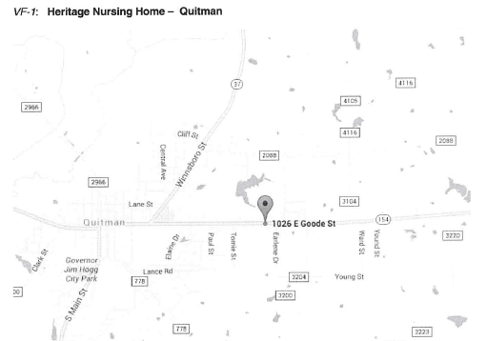

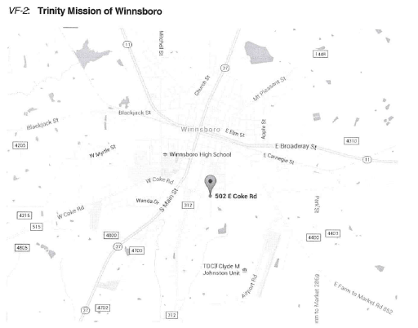

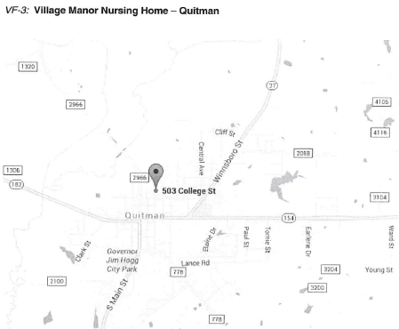

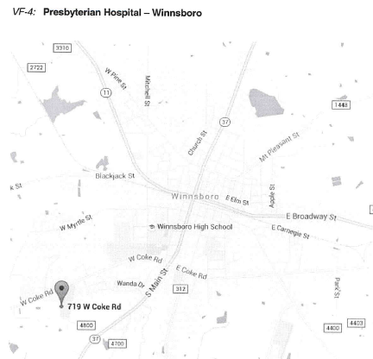

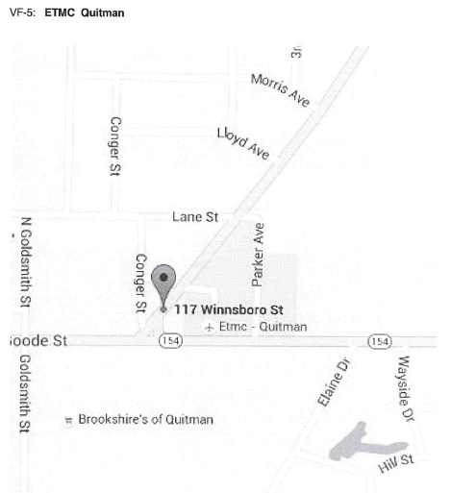

REGULATED FACILITIES

For emergency contact numbers for these facilities, see the Emergency Contact Roster.

- Regulated Facilities

ID#: F1 Name: Nestle Waters Address: 3265 FM 2865 Hawkins, TX.
Primary Chemical Hazard: Ammonia
Protective Action Distance: ½ mile
Estimate Population at Risk: 2000

ID#: F2 Name: New Hope Special utility district
Address: 413 CR 2651 Mineola, TX.
Primary Chemical Hazard: Chlorine
Protective Action Distance: 1/2 mile
Estimated Population at Risk: 5000

HAZARDOUS MATERIALS THREAT MAP - REGULATED FACILITIES

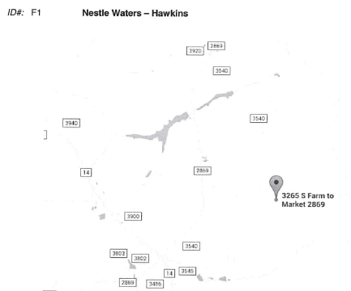

ID #: F2 New Hope Special Utility District

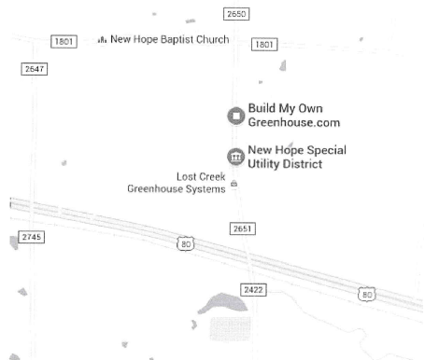

HAZARDOUS MATERIALS TRANSPORTATION ROUTES

- Highways

ID#: H1 Route: US Highway 80
Primary Chemical Hazards: Major East-West corridor for all types of transportable goods
Protective Action Distance: ½ mile
Additional Information:

ID#: H2 Route: Texas Highway 154
Primary Chemical Hazards: Secondary East-West Corridor for all types of transportable goods
Protective Action Distance:
Additional Information:

- Railroads

ID#: R1 Route: East- West
Primary Chemical Hazards: All

- Pipelines

ID#: P1 Route: All over county
Primary Chemical Hazard: Gas and oil
Protective Action Distance:1/2 mile

HAZARDOUS MATERIALS THREAT MAP - TRANSPORTATION ROUTES

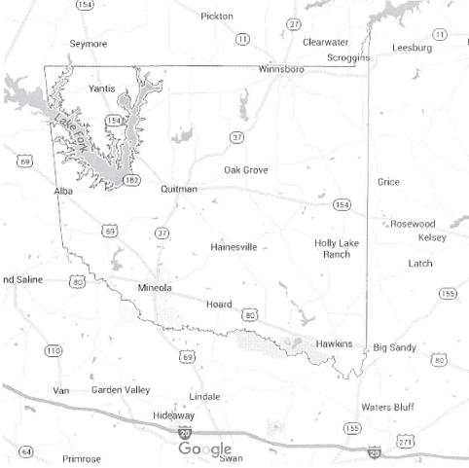

EVACUATION ROUTES FOR REGULATED FACILITY RISK AREAS

Evacuation routes in this annex are for the risk areas surrounding the regulated facilities described and depicted in Appendix 6.

Primary Evacuation Route Alternate Evacuation Route

ID#: F1
Name: Nestle Water Company Hwy 2869 Hawkins County roads out of plant

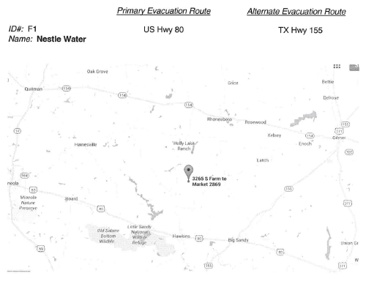

ID#: F2
Name: New Hope Water Hwy 80 Mineola FM 1801 Mineola

